

SCHOOL OF Business Analytics

ASSIGNMENT COVER SHEET

STUDENT DETAILS
Student name: |  |  |  | Namesh Panneer Selvan |  |  |  |  |  | Student ID number: |  |  |  | 22148363

UNIT AND TUTORIAL DETAILS
Unit name: |  |  | Integrated Business Experience |  |  |  |  |  |  |  |  | Unit number: |  |  | 7050
Tutorial group: |  |  |  |  | 15 |  |  |  |  |  | Tutorial day and time: |  |  |  |  | 25 April 2025
Lecturer or Tutor name: |  |  |  |  |  |  | Dr Wade Azmy

ASSIGNMENT DETAILS
Title: |  | The Chair of Honeywell on Bringing an Industrial Business into Digital Age
Length: |  | 1000 |  |  |  |  | Due date: | 25 April 2025 |  |  |  |  | Date submitted: |  |  |  | 25 April 2025
Home campus (where you are enrolled): |  |  |  |  |  |  |  |  | Parramatta City Campus

DECLARATION
✓  Yes Yes  y | I hold a copy of this assignment if the original is lost or damaged.
✓ | I hereby certify that no part of this assignment or product has been copied from any other student’s work or from any other source except where due acknowledgement is made in the assignment.
✓ | I hereby certify that no part of this assignment or product has been submitted by me in another (previous or current) assessment, except where appropriately referenced, and with prior permission from the Lecturer / Tutor / Unit Coordinator for this unit.
✓ | No part of the assignment/product has been written/produced for me by any other person except where collaboration has been authorised by the Lecturer / Tutor /Unit Coordinator concerned.
✓  Yes | I am aware that this work will be reproduced and submitted to plagiarism detection software programs for the purpose of detecting possible plagiarism (which may retain a copy on its database for future plagiarism checking).
Student’s signature: |  |  |  |  |  | Namesh Panneer Selvan
Note: An examiner or lecturer / tutor has the right to not mark this assignment if the above declaration has not been signed.

ARO 00380 08/15

Integrated Business Experience - Assessment 1
The Chair of Honeywell on Bringing an Industrial Business into Digital Age

Introduction:

The report focuses on the digital transformation of Honeywell based on the details shared by Chairman Darius Adamczyk, where he identifies the transition towards data integration, infrastructure simplification, and digital innovation. He has also shared insights on leadership, cultural transformation, and strategy for any technological disruption.

Determining Factors:

Honeywell's digital transformation, as detailed in the case study "The Chair of Honeywell on Bringing an Industrial Business into the Digital Age," was influenced by several key determining factors:​

The former CEO and current Chairman Darius Adamczyk, guided Honeywell towards a strategic digital transformation journey. He emphasised the importance of internal modernisation and the development of innovative digital solutions for customers, focusing on data integration, infrastructure simplification, and software-driven value creation. (Darius Adamczyk, Harvard Business Review 2024)

The transformation started by reducing over 150 ERP systems and 2,700 applications. (Amr Elharony, LinkedIn 2024)

The need to harness the vast amounts of data generated by its systems was recognised by centralising the data and aimed to improve the productivity, transparency, and agility by enabling more informed business decisions. ​(Darius Adamczyk, Harvard Business Review 2024)

The help of advanced technologies like AI, IoT, and edge computing has enhanced operational efficiency and product innovation. (Paras Sharma & Suruchi Dhingra, Transforma Insights 2025)

The company externally sought to offer clients an enhanced value by providing tools to save energy, track carbon emissions, and improve safety. This customer-centric approach drove the development of new digital products and services. (Darius Adamczyk, Harvard Business Review 2024)

Honeywell recognised the challenges posed by under-skilled technology resources and invested in upskilling the workforce to ensure a successful implementation and adoption of digital initiatives. (Honeywell 2024)

The partnership with Microsoft played a pivotal role in the company's journey towards digital transformation. Honeywell advanced its digital initiatives across various industries with the help of Microsoft Cloud and AI capabilities. (Honeywell 2024)

Honeywell partnered with Google to integrate AI technologies, which played a pivotal role in the growth of digital transformation. (Reuters 2024)

The capabilities in occupant experience and life science were expanded due to strategic acquisitions, such as Sine and Sparta. (Honeywell Forge n.d.)

With the increasing regulatory standards Honeywell is compelled to build the digital capabilities like emission tracking, automated reporting to meet the evolving standards. It became essential for them to prepare digital scorecards and transparent data flow in order to stay compliant with the regulations. (Dimitrios Stamoulis & Evangelia Kopanaki 2024)

Decarbonisation and energy transition which are the two major focus of Honeywell have increased the demand for digital tools in the market for monitoring carbon emission and energy optimisation with autogenerating digital reports are transforming sustainability. With the help of these digital tool’s companies are able to track their sustainability and have a competitive advantage in the market.
(Jin Wang, Zihan Hong & Hai Long 2023)

Additionally, the creation of a centralised data warehouse with the amalgamation of legacy systems improved data analytics and decision-making. (Nausad Modasiya, The Free Press Journal 2024)

Due to these collective factors, Honeywell was able to navigate challenges like the COVID-19 pandemic and geopolitical risks, ensuring resilience and sustained growth. (Darius Adamczyk, Harvard Business Review 2024)

Internal & External Components:

The digital transformation of Honeywell was influenced by a combination of internal and external components.

Internal Components:

- Strategic Leadership: The CEO Darius Adamczyk, took a crucial decision in driving the digital transformation forward by highlighting the importance of centralising digital technologies across all business units. (Darius Adamczyk, Harvard Business Review 2024)

- Operational Development: To create a more agile organisational structure, Honeywell went through an internal restructuring by reducing over 150 ERP systems and 2700 applications to simplify operations and enhance the efficiency of the organisation. (Amr Elharony, LinkedIn 2024)

- Data Amalgamation: The company focused on consolidating its data across various platforms, enabling a data-driven culture for better decision-making, which helped them in enhancing their internal processes and customer offerings. (Amr Elharony, LinkedIn 2024)

- Workforce Development: The organisation had recognised the need for development of its workforce to improve their digital proficiency by investing in providing training programmes to upskill employees to operate and innovate within the new digital framework. ​(Gary Smith, Fern Fort 2025)

- The Integration of Enterprise Data Warehouse: The company took over some large transformation projects, a step towards unifying SAP ECC, SAP S/4 HANA, and over 15 legacy systems within their Enterprise Data Warehouse to consolidate the data and enhance their consistency and analytics. (Nausad Modasiya, The Free Press Journal 2024)

- Establishment of Innovation Labs: They established dedicated innovation labs for the purpose of experimentation with new technologies. This encouraged intrapreneurship through cultural programmes like hackathons. (Nausad Modasiya, The Free Press Journal 2024)

External Components:

- Growing Customer Preferences: With evolving customer demands for more efficient products and solutions, the organisation was forced to create an innovative system that meets the expectations of its customers. (Blake Morgan, Forbes 2019)

- Advanced Technology: Technologies like AI, IoT, and edge computing created an opportunity for Honeywell to improve its operational capabilities. (​Paras Sharma & Suruchi Dhingra, Transforma Insights 2025)

- Merger and Acquisition: Honeywell was able to integrate cutting-edge technologies through a strategic partnership with Sine and Sparta to provide advanced quality management software. (SGS Case Study n.d.)

- Partnership with Fictiv: The collaboration of Honeywell with Fictiv enabled them to accelerate product development cycles using digital manufacturing techniques by ensuring rapid production. (Rob Moran 2024)

- Regulatory Rules and Regulations: With emphasis on sustainability awareness and increasing regulatory requirements, Honeywell has adopted digital solutions that ensure compliance with the latest rules and regulations in the market. (Fern Fort 2025)

The digital transformation by Honeywell was a complex initiative driven by its internal and external components, and the ability to align it effectively was a successful transition.

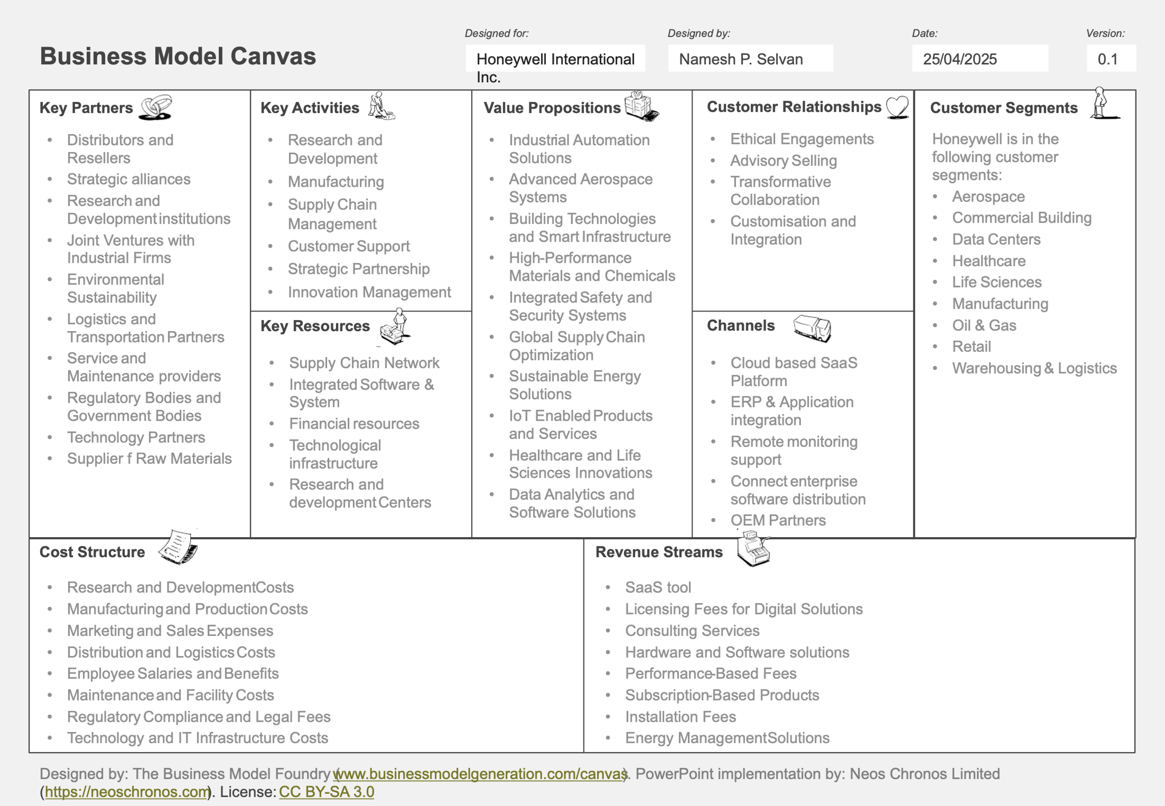

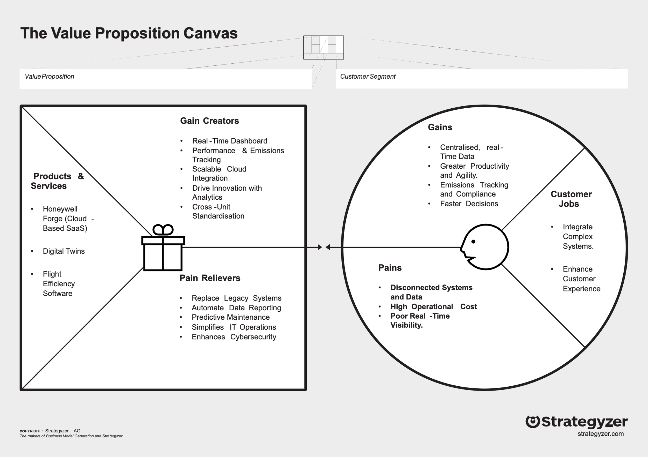

Reference list:

Adamczyk, D 2024, ‘The Chair of Honeywell on Bringing an Industrial Business into the Digital Age’, Harvard Business Review, 1 March, viewed 25 April 2025,
<https://hbr.org/2024/03/the-chair-of-honeywell-on-bringing-an-industrial-business-into-the-digital-age>

Elharony, A 2024, ‘In an era where digital transformation is more than just a buzzword, Honeywell’s journey from an industrial giant to a digital powerhouse is nothing short of inspirational. Under the leadership of Darius Adamczyk, Honeywell has navigated through the storms of Covid, inflation, and geopolitical risks’, Linkedin.com, 26 May, viewed 25 April 2025,
<https://www.linkedin.com/pulse/how-honeywells-digital-makeover-winning-future-lessons-amr-elharony-favpf/>

Fern Fort University 2025, ‘Honeywell SWOT Analysis, Weighted SWOT Analysis, SWOT Matrix Solution | Assignment Help’, Fernfortuniversity.com, 2 April, viewed 25 April 2025, <https://fernfortuniversity.com/essay/swot1/honeywell-179>

Honeywell 2024,’The Future Is... Embracing Transformation - With CFO Greg Lewis’, Honeywell.com, 9 May, viewed 25 April 2025,
<https://www.honeywell.com/us/en/podcast/the-future-is-embracing-transformation-with-cfo-greg-lewis>

Honeywell 2024, ‘Empowering the Future Together: How Honeywell and Microsoft Are Driving Innovation Across Industries’, Honeywell.com, viewed 25 April 2025, <https://www.honeywell.com/us/en/news/2024/09/how-honeywell-and-microsoft-are-driving-innovation-across-industries>

Honeywell Forge n.d., ‘Reimagining The Digital Transformation Playbook’, Honeywellforge.ai, viewed 25 April 2025,
<https://www.honeywellforge.ai/us/en/campaigns/connected-forum/reimagining-digital-trasformation>

Modasiya, N 2024, ‘Success Stories In Enterprise Data Integration: Vaidheyar Raman Balasubramanians Honeywell Case Study’, Free Press Journal, 10 December, viewed 25 April 2025, <https://www.freepressjournal.in/latest-news/success-stories-in-enterprise-data-integration-vaidheyar-raman-balasubramanians-honeywell-case-study>

Moran, R 2024, ‘Honeywell’, Fictiv, 14 May, viewed 25 April 2025,
<https://www.fictiv.com/case-studies/honeywell>
Morgan, B 2019, ‘We Are Future Shapers: Enterprise Transformation At Honeywell’, Forbes, 5 September, viewed 25 April 2025,
<https://www.forbes.com/sites/blakemorgan/2019/09/05/we-are-future-shapers-enterprise-transformation-at-honeywell>

Reuters 2024, ‘Honeywell partners with Google to integrate data with generative AI’, Reuters, 21 October, viewed 25 April 2025,
<https://www.reuters.com/technology/artificial-intelligence/honeywell-partners-with-google-integrate-data-with-generative-ai-2024-10-21/>

Honeywell n.d., ‘SGS CASE STUDY’, Honeywell Sparta System, viewed 25 April 2025, <https://hcenews.honeywell.com/rs/hce/images/SGS-Case-Study.pdf>

Sharma, P and Dhingra, S 2025, ‘Honeywell: Digital Transformation capabilities assessment - Reports & Insights’, Transformainsights.com, viewed 25 April 2025, <https://transformainsights.com/research/reports/honeywell-digital-transformation-capabilities-assessment>

Smith, G 2025, ‘Honeywell: Transforming a Century Old Industrial Case Study Solution, General Management Case Solution | Assignment Help’, Fernfortuniversity.com, 3 April, viewed 25 April 2025, <https://fernfortuniversity.com/essay/genmgt_case/honeywell-transforming-century-old-industrial-237>

Stamoulis, D and Kopanaki, E 2024, ‘Regulatory compliance as a driver for digital transformation: the case of the railway sector in Europe’, Procedia Computer Science, 1 January, viewed 25 April 2025, <https://www.sciencedirect.com/science/article/pii/S1877050924014650>

Wang, J, Hong, Z and Long, H 2023, ‘Digital Transformation Empowers ESG Performance in the Manufacturing Industry: From ESG to DESG’, SAGE Open, 1 October, viewed 25 April 2025, <https://journals.sagepub.com/doi/pdf/10.1177/21582440231204158>

